Appetizers Name: ___________________________ Period: ______ Date: ______________
Day # | Description | ↓  Too Low | Too High  ↑ | My Estimate | My Reasoning | Answer | Error | |Error|  as a %
+
–
+
–
+
–
+
–
+
–
Math Talks | Would You Rather? | Would You Rather?

Visual Pattern # _______
Graphing Stories
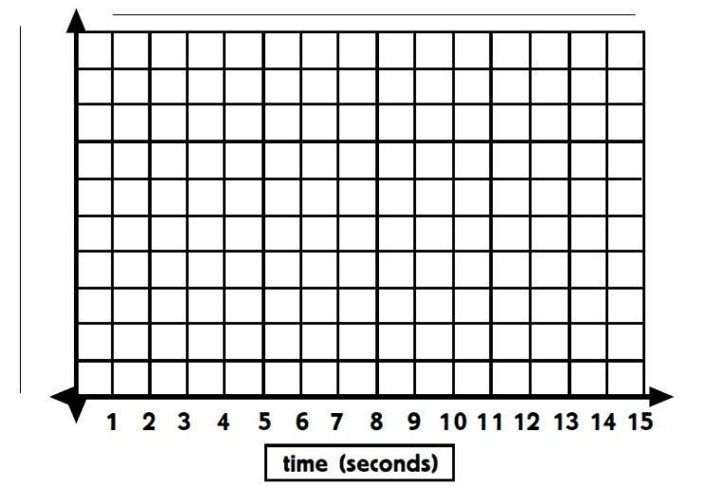
- Draw the next step:

- Complete this table:
Step # | # of _______________
1
2
3
4
5
… | …
10
… | …
27

- What is happening with each step?

- What is the rule for how each step (y) relates to the number of items (x)?

